**AEE 342: Aerodynamics, Project 1c – Analysis of Symmetric Airfoils**

**Submitted: 02/06/15**

In the simulation of flow behavior, it is important to properly constrain the system with fundamental ‘rules’ that reflect the laws of the physical system being modelled. These constraints to fluid behavior often seem trivial when observing a physical system, but may require some clever use of mathematical principles in order to force a simulation to behave a certain way. Throughout the course of this investigation of flowfields and their behavior, such principles are applied to model several systems and to fine-tune their properties. The simulated flow was introduced to two different solid bodies. The shapes of these bodies were defined by placing some number of sources and sinks. Sources and sinks are point singularities that repel and attract a simulated flow, respectively. That is, they are points that radially emanate infinitely many vectors with magnitudes equal to the source’s or sink’s strength, . This is a valuable construct in the simulation of fluid flows because sources and sinks may be placed in order to induce a certain curvature in the flowfield. As more points are placed, a boundary can become sufficiently defined so as to simulate the normal forces induced on the flowfield by the object being modelled. However, the curvature and force of a physical surface is continuous, while the number of sources/sinks placed must be finite. This issue is addressed in detail throughout this investigation, with visual evaluation of the accuracy of simulated airfoils as well as a comparison with table values of airfoil performance with varying numbers of sources and sinks.

The investigation began with the modelling of an object that appeared similar to a bowling pin. This was a simple model using only three sources/sinks, but provided valuable insight into the nature of flowfields through a number of intuitive visualizations. This flowfield was described by the following equations.

where , , . The primary components of these equations are the positions and strengths of the sinks, as well as the velocity of the freestream. The first three terms in each equation are the equations describing the three sinks. The final constant term, which is only found in the equation for , represents the velocity of the freestream. Here, it can be seen that the flowfield described has a freestream velocity of 1 in the x-direction and has three major changes in curvature. By integrating these velocity functions numerically, the position of the flow on an arbitrary number of streamlines can be determined and plotted. The resulting streamlines and airfoil shape can be seen below. An additional visualization of the simulation that was useful for an intuitive understanding of the system was the contour plot, displaying the velocity distribution across the entire field. These two visualizations of the flow complemented each other very well, with streamlines describing the movement of the flow near the modelled surface, and the contour plot providing insight into the gradual and abrupt changes in velocity throughout the entire field.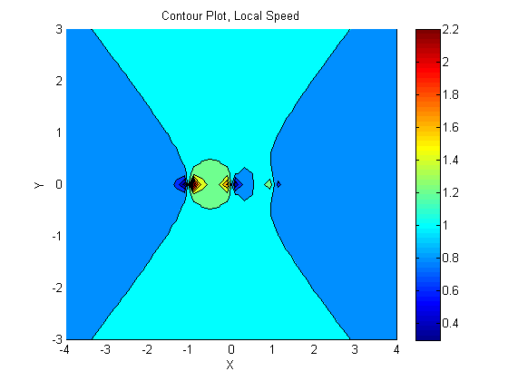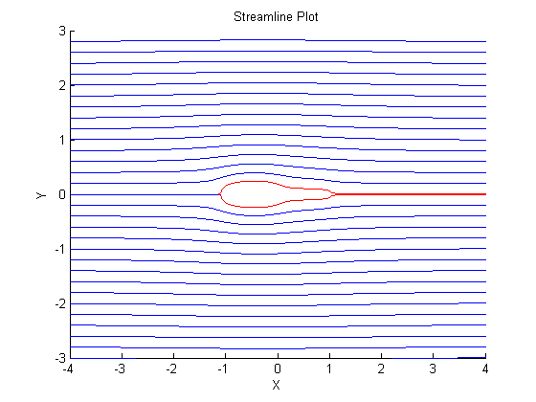 On the streamline plot, an additional pair of streamlines is plotted near the center, beginning from the stagnation point at the leading edge of the object. These streamlines trace the surface of the object and reveal much about its shape. This is a strategy that will be employed many times throughout the investigation. On the contour plot, particularly noteworthy areas can be identified by drastic changes in velocity, such as the stagnation point. The general sweeping curves of the plot are informative too, possibly suggesting an apparent pressure gradient throughout field.

Next, the general forms of the velocity field equations were introduced in order to derive equations particular to a NACA 0015 airfoil. Here, several mathematical relations derived from physical characteristics were used to constrain the flowfield. First, the flowfield velocities were defined by

where is the total number of sources/sinks and is the particular source/sink number. Here, the freestream velocity is again set to 1, while remaining velocities will be influenced by the determined source/sink strengths. The first constraint to this system is the equation for the shape of a NACA airfoil, given by

where = 15 for a NACA 0015 airfoil. Although the shape of the airfoil can now be determined, another relation must be applied in order to relate it to the velocity functions. In order to match streamlines to the surface of the airfoil, the system can be constrained by setting the stream function equal to zero at all points on the airfoil. This yields the equation

where subscript refers to a point on the airfoil’s surface.